Commonwealth of Massachusetts
Executive Office of Health and Human Services
Department of Transitional Assistance

CHARLES D. BAKER MARYLOU SUDDERS
Governor Secretary

KARYN POLITO JEFF McCUE
Lieutenant Governor Commissioner
July 31, 2019
«Business_name»
«Address»
«CITY», «State» «Zip_Code»

This letter is being sent both as a reminder of retailer responsibilities around the proper use of Electronic Benefit Transfer (EBT) cards and to solicit your support of DTA’s enforcement of the laws that govern the use of EBT cards.
Sections 5I and 5J of Massachusetts General Laws, Chapter 18, prohibit the acceptance of direct cash assistance, administered through EBT cards, for the purchase of certain items (e.g., alcoholic beverages, cigarettes, lottery tickets) and prohibit EBT cards from being accepted by certain types of retailers (e.g., liquor stores, bars).
To ensure full compliance, DTA is implementing a multi-faceted and proactive strategy which includes, but is not limited to, the following:
- New regulations and policies reflecting DTA’s full authority under the law;
- Education and training to support retailers;
- DTA-approved signage available for retailer usage;
- Merchant Category Code (MCC) blocking of EBT cards at prohibited retailers;
- Secret shoppers and data mining to identify retailers suspected of violating the law;
- Levying of fines (up to $2,500 for multiple violations);
- Referral of noncompliant retailers for potential suspension or revocation of licenses; and
- Partnerships with local law enforcement for targeted investigations.

In addition, DTA is working with other state agencies that regulate and license the sales of tobacco, liquor, and the state lottery to establish streamlined procedures for suspension or revocation of state-issued licenses, when appropriate.
Retailers who knowingly violate these laws are subject to serious penalties. Since the majority of retailers are interested in being fully compliant with Massachusetts laws, we are seeking your assistance as partners to help support DTA’s enforcement strategy. DTA aims to ensure that all retailers understand both requirements of Chapter 18 and the ramifications of violation, as well as have the necessary resources and materials to support compliance. With your help, DTA can provide its services and benefits in a manner that meets the highest standards of program integrity and is wholly consistent with Massachusetts laws.
Please visit our website www.mass.gov/dta/retailers (or call 800-372-8399) for training and educational materials, to request to be sent store signage, or to request additional information. Thank you for your assistance with this important initiative.
Sincerely,
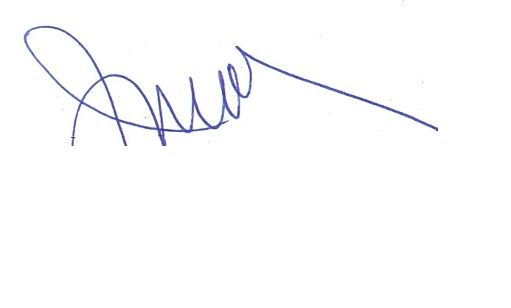
Jeff McCue

